ASSIGNMENT -III

BUILD CNN MODEL for CLASSIFICATION of FLOWERS

# Assignment Date 30 September 2022 Student Name Annie JR

Student Roll Number 963619104001

# Maximum Marks 2 Marks

## Question-1:

Download the dataset

## Question-2:

Image Augmentation

## Solution

from tensorflow.keras.preprocessing.image import ImageDataGenerator train_datagen=ImageDataGenerator(rescale=1./255,zoom_range=0.2,horizontal_flip=True,vertical_flip=T r ue)

test_datagen=ImageDataGenerator(rescale=1./255)

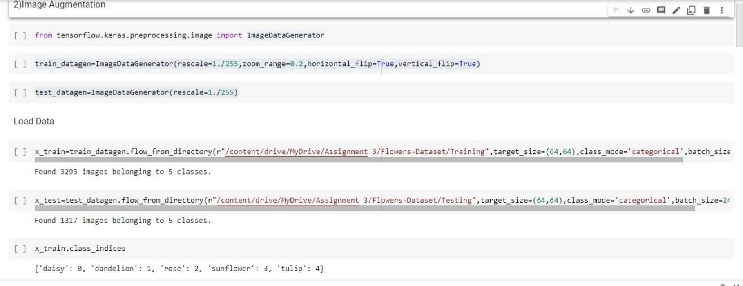

## Question-3:

Create model

## Solution

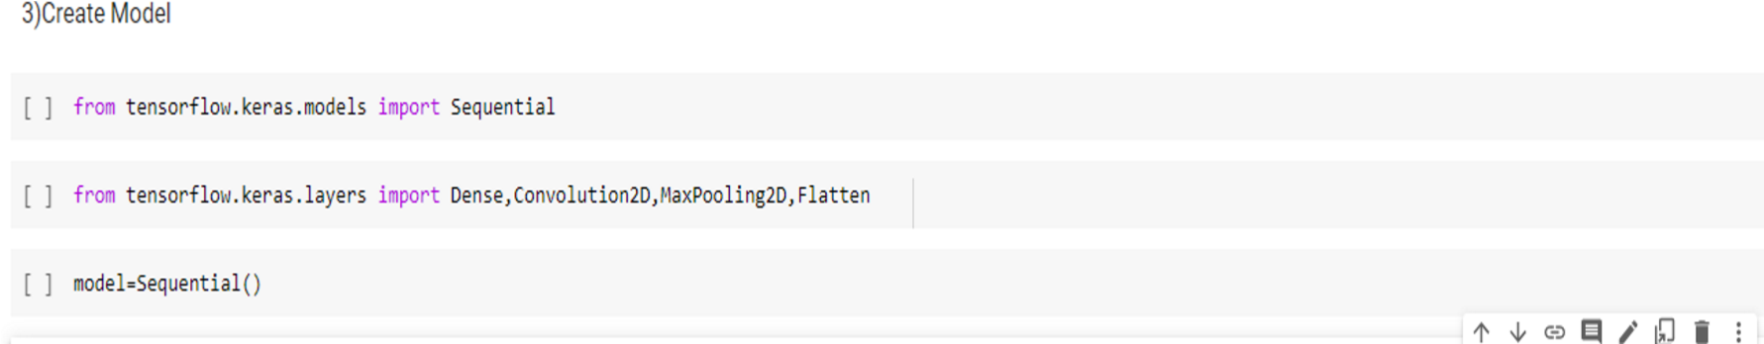from tensorflow.keras.models import Sequential from tensorflow.keras.layers import Dense,Convolution2D,MaxPooling2D,Flatten model=Sequential()

## Question-4:

Add Layers (Convolution,MaxPooling,Flatten,Dense-(Hidden Layers),Output)

## Solution a)Convolution Layer

model.add(Convolution2D(32,(3,3),kernel_initializer="random_uniform",activation="relu",strides=(1

,1),input_shape=(64,64,3)))

## MaxPooling Layer

model.add(MaxPooling2D(pool_size=(2,2)))

## Flatten Layer

model.add(Flatten())

1. **Dense(Hidden layer)** model.add(Dense(300,activation="relu")) model.add(Dense(300,activation="relu"))

## Output layer

model.add(Dense(5,activation="softmax"))

## Question-5:

Compile The Model

## Solution

model.compile(loss="categorical_crossentropy",metrics=['accuracy'],optimizer='adam')

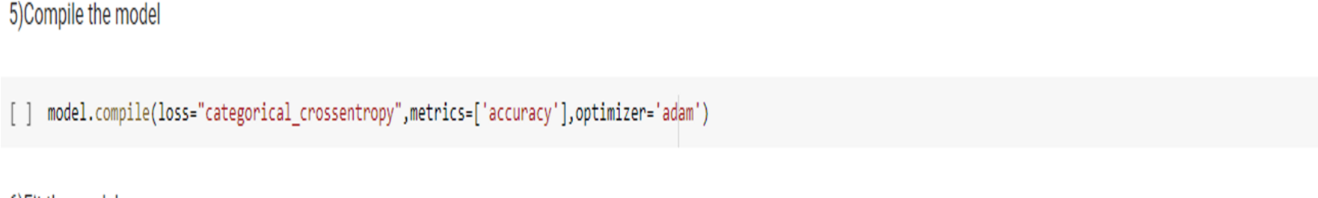

## Question-6:

Fit The Model

**Solution** model.fit(x_train,epochs=5,steps_per_epoch=len(x_train),validation_data=x_test,validation_steps=l en(x_test))

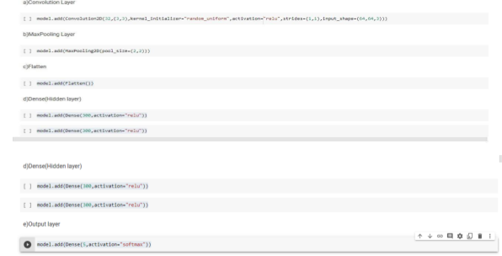

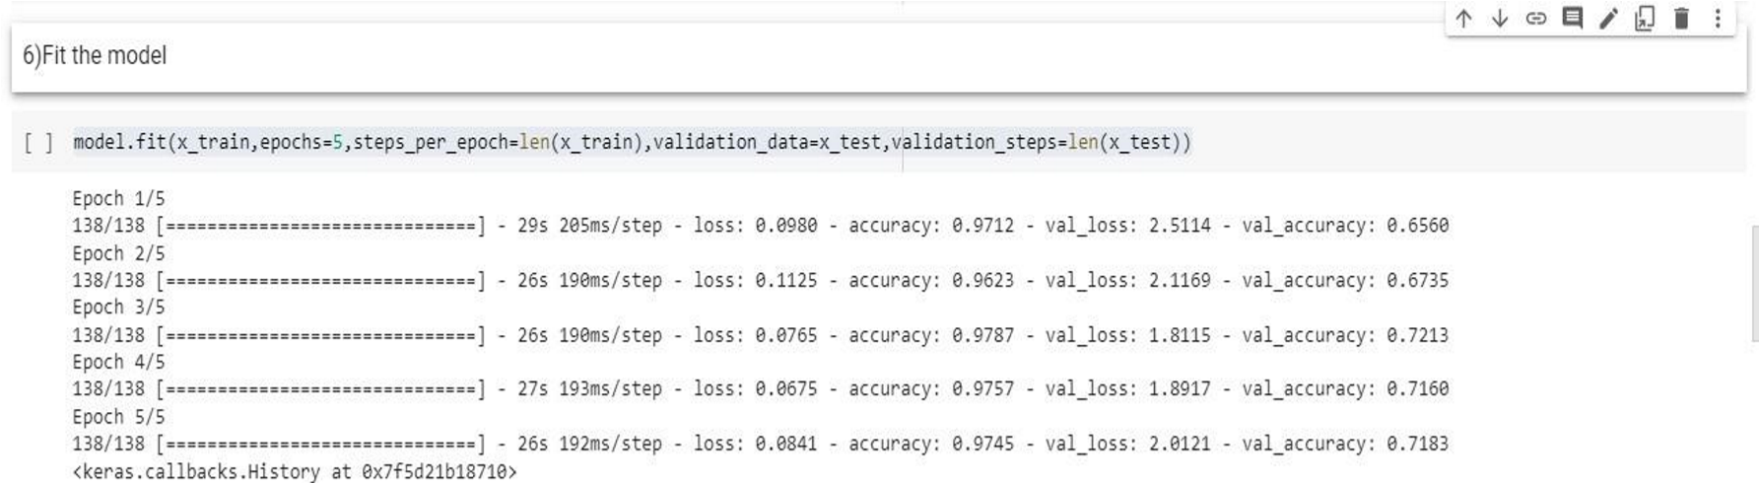

## Question-7:

Save The Model

## Solution

model.save("Flowers.h5")



## Question-8:

Test The Model

**Solution** import numpy as np

from tensorflow.keras.models import load_model from tensorflow.keras.preprocessing import image model=load_model("Flowers.h5")

img=image.load_img(r"/content/drive/MyDrive/Assignment 3/Flowers- Dataset/Testing/daisy/14333681205_a07c9f1752_m.jpg",target_size=(64,64)) x=image.img_to_array(img) x=np.expand_dims(x,axis=0) pred=model.predict(x) pred index=['daisy','dandelion','rose','sunflower','tulip'] index[np.argmax(pred)]

